Guidelines for applicants
These guidelines for applicants relate to the OFFERR project opened on 03/04/2023 and aim to facilitate the preparation of the project proposal and to clarify the steps after the application submission. The entire process is summarized on the following application process flowchart.

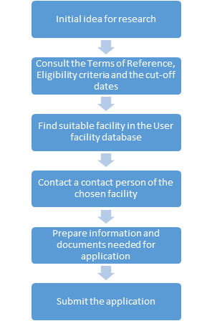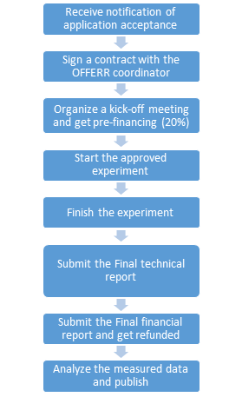
Figure 1 – Flowchart of the preparation of the application (left) and the steps after the application acceptance (right).

- First, an applicant shall get familiar with the conditions described in the Terms of Reference document and the Eligibility criteria document.
- An applicant can use the European User Facility Network (EUFN) brochure to choose the infrastructure(s) for performing the experiment.
- An applicant shall contact the contact person of the chosen infrastructure and agree on the content and timing of the experimental campaign. This could be made using the OFFERR Interactive Forum.
- An applicant shall prepare a project proposal that includes the commitment of the infrastructure provider on availability and costs. The costs should be described in detail.
- Applications shall be submitted through the electronic application submission system available at [https://offerr.flexx.camp/]. The application consists of the filled webform and three (for fast-track applications) or four (for complex application) uploaded documents for fast-track applications (Technical proposal, Financial proposal, Engagement document, Intellectual property agreement).
- After the application submission, the applicant will receive a confirmation email.
- The submitted applications will be reviewed and ranked.
- After the end of the evaluation process (including SNETP SIIC), applicants will receive a notification of application acceptance or rejection.
- The applicant signs a contract (Subaward Agreement) with EDF (being the OFFERR coordinator) to receive funding.
- The approved experiment should start within 12 months after the notification of the approval. Prefinancing (20%) is given in exchange of a proof of the start of the application (kick-off meeting minutes) and the Subaward Agreement signed by EDF/OFFERR coordinator and the applicant who will receive the funds.
- The approved experiment should finish within 6/18 months in case of fact-track/complex projects and not later than 2 months before the end of the OFFERR project.
- The users should write and submit the User report. Infrastructure contact person should write and submit the Infrastructure report and the open data (within 2 months after the end of the experiment). These documents together represent the Final Technical Report.
- The applicant declares the costs, gets refunded and distributes the money to the other partners of the project. This is the Final Financial Report. In case the total budget the applicant receives from OFFERR is bigger than 300 kEUR, then the applicant reports its costs to the EC portal.
- The Users analyze the measured data and publish them (not funded by OFFERR).

The Users are encouraged to submit the raw data to the OFFERR platform. If it is not possible, the Users should explain the reasons why it is not possible.

