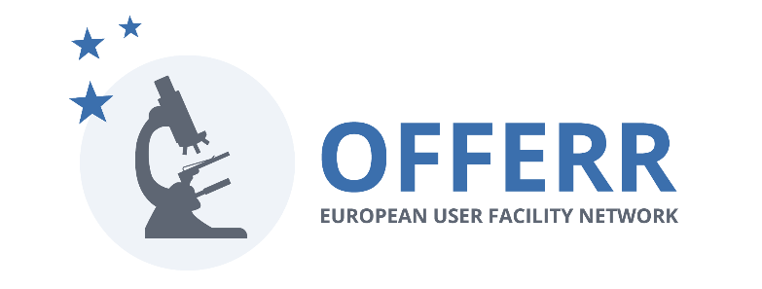

OFFERR

OFFERR Eligibility criteria

Date: 09 04 2024

- It is mandatory that “Users” (the visiting team composed of one or more researchers) and “Infrastructure Providers” provide the “Engagement document” signed by all involved parties in the proposal for an “Infrastructure project” in accordance with the Terms of Reference. This agreement shall include the commitment of the infrastructure provider on availability and costs to be charged for the work described in the application.
- Topics
The proposals shall aim at strengthening the leadership of the European union in the field of civil nuclear fission research, development and innovation.
The topics to be considered should also be aligned with the SNETP mission that is to support safe, reliable, and efficient operation of civil nuclear systems. This includes the following call areas:
- Light Water Reactor sustainability,
- Advanced fission reactor concepts,
- Waste and decommissioning,
- Nuclear science applications,
- Advanced nuclear fuels,
- Innovation in nuclear instrumentation,
- Radioprotection and nuclear medicine.
Depending on the OFFERR strategy, call areas may vary from one cut-off date to another. This will be announced at least 3 months before the cut-off date.
- Funding
  - The project consortium shall be composed of at least two entities (i.e. Users and Infrastructure providers) from different countries. At least one of them shall come from an EU member state or an associated country. International facilities (as JRC) are considered a different EU member state independently of the affiliation of the visiting research team.
  - The non-EU partners of the project consortium are not eligible for funding. Proof of their funding part must be joined or explained during in the project proposal.
  - The maximal budget of a fast-track project funded by OFFERR is 50 kEUR.
  - The maximal budget of a complex project funded by OFFERR is 1 MEUR. If an application exceeds this amount, it can still be approved and receive the maximal support if the applicants show that they have all the remaining parts of the project funded elsewhere.
- Timing
  - The OFFERR funded projects must:
    - start not later than 12 months after the date of the proposal approval;
    - be completed at the latest by the end of June 2026
    - be completed in less than six months (fast-track projects) or 18 months (complex projects) of the access to the infrastructure.
- Intellectual property agreement
The Complex Project application should contain a draft of an intellectual property agreement between the project partners.

