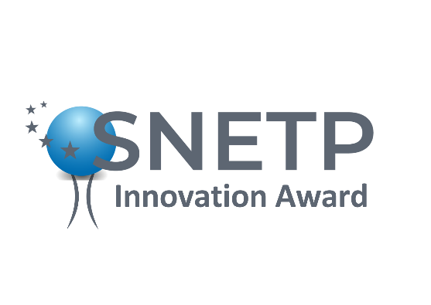
Call for Applications: SNETP to launch Innovation Award at the SNETP Forum 2024

Happening in Rome from April 17th to 19th, the SNETP Forum is set to grant awards aimed at fostering innovation within the nuclear sector.

SNETP is proud to showcase the Italian innovation, skills and competences in its annual Forum 2024 host country thanks to the support and the sponsorship of many Italian partners such as Edison, ENEA, CIRTEN, AIN, …. Thus, awards will be granted to young PhD/master students that have accomplished their degree in an Italian institution (academia, R&D center, Industry) in the nuclear field between 2022 and 2026.

Recognizing that students represent the future of the EU nuclear industry, we are excited to announce a unique opportunity during our gala dinner on April 18th: winners will have the exciting opportunity to pitch their topics in front of the large and diverse audience that will attend the prestigious SNETP gala dinner, gathering representatives from industrial sectors, research and development organizations, academia, TSO, SMEs, and non-governmental bodies.

These unique awards will serve as a platform to highlight ground-breaking advances in nuclear technology and research. Three categories of awards are available to doctoral students based in Italy:
- The Jury Award, awarded by a panel of experts hailing from academia, industry, and TSO (Technical and Scientific Organizations)
- The Peer Award, based on an evaluation made by the candidates themselves
- The SNETP Innovation Award, awarded by members of the SNETP Committee for Scientific and Industrial Innovation, composed of members of the SNETP Governing Board. The award will be granted to promising PhDs conducting work on innovative topics within the nuclear field.
The call for applications will be initiated by February 26th. Prospective applicants will be required to submit their proposals, encapsulating their PhD topic, research objectives, identified challenges, methodology employed, and collaborations, all within a concise maximum of two pages.

Winners will receive symbolic prizes along with the SNETP recognition signed by the President and Vice President.
Up to 15 eligible candidates will be exempted from any fees to attend the SNETP Forum.

Applications can be submitted by March 20th. Eligible candidates will be notified by March 22nd and results will be known by the first week of April.

Call document: Innovation Award at the SNETP Forum 2024

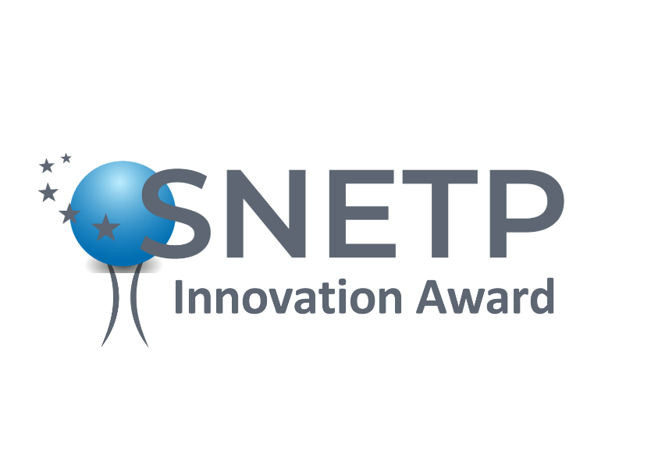

SNETP Innovation Award

Guidelines for applicants
Evaluation and eligibility Criterion

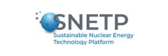
Date: 26/03/2024

Guidelines for applicants

These guidelines for applicants relate to the SNETP Innovation Award opened on 26/02/2024 and aim to facilitate the preparation of the application and to clarify the steps after the application submission. The entire process is summarized in the following application process flowchart:
26/02/2024 | Consult the guideline for applicants and prepare the information and documents needed for application. Submit the application
20/03/2024 | Closure of the applications
22/03/2024 | Notification sent to eligible candidates
4/04/2024 | Notification sent to the awardees
18/04/2024 | Pitch during the SNETP Gala Dinner

Scope
The SNETP Forum 2024 will be the occasion to grant awards aimed at fostering innovation within the nuclear sector. Three awards will be offered on behalf of SNETP with the aim to promote interactions between the established nuclear R&D and industrial actors and the young generation of engineers and researchers.

Purpose
- The awards shall help successful candidates to enlarge their network of professional contacts and further develop international collaboration by working on their research and/or innovation topic with European and international sectorial experts and professionals.
- Winners will have the opportunity to pitch their topics (5 min speech) in front of the large and diverse audience of the SNETP gala dinner, gathering representatives from industrial sectors, research and development organizations, academia, TSO, SMEs, and non-governmental bodies.
- Winners will receive prizes (a tablet, laptop, or other gadgets) along with a SNETP diploma signed by the President and Vice President. Up to 15 eligible candidates will be exempted from any fees to attend the SNETP Forum.

The 3 awards
Three categories of awards are available to doctoral students based in Italy:
- The Jury Award, awarded by a panel of experts hailing from academia, industry, and TSO (Technical and Scientific Organizations)
- The Peer Award, based on an evaluation made by the candidates themselves
- The SNETP Innovation Award, awarded by members of the SNETP Committee for Scientific and Industrial Innovation, composed of members of the SNETP Governing Board. The award will be granted to promising PhDs conducting work on innovative topics within the nuclear field.

Application form
- Structured CV (1 page max)
- 2-pages application form including:
      - Short summed up biography about the applicant (500 words max)
      - Short description of the personal project and its timeline and the motivation of the applicant (500 words max)
      - PhD topic - explain your research objectives, identified challenges, methodology employed, and collaborations (500 words max)
Award Selection criteria
Eligible candidates are individuals who are currently enrolled in or have completed their doctoral studies (PhD) in the nuclear field at an Italian institution between 2022 and 2026.

- The three Awards will be evaluated based on the following criterion:
  - PhD field of research and its compatibility with SNETP SRIA (out of 5) ;
  - Motivation (out of 5) ;
  - Innovation aspect of the project (out of 5).
For each criterion, a minimum threshold of 3 points is required. The total score is calculated as the sum of the scores of the three main criteria. Successful candidates will need to obtain at least 10 points out of 15. The applications are ranked based on the total scores given by the reviewers.
The evaluation matrix will serve as a basis for a fair, transparent, and efficient selection process. In case of equal scores, the score on “Innovation aspect of the PhD” will be decisive.
Application submission deadline is March 20th, 2024. Send your applications to secretariat@snetp.eu with the subject line “Innovation Award”.
Legal effects of the invitation
Applicants who submit a proposal and proceed to the next stage agree to actively participate in the Peer Award evaluation phase. This includes completing the evaluation matrix, which assesses nominated projects according to predetermined criteria, providing thoughtful feedback to peers, and attending mandatory evaluation discussions. Your valuable insights will help shape the selection process and ensure a fair and transparent outcome.

Application document: Innovation Award at the SNETP Forum 2024

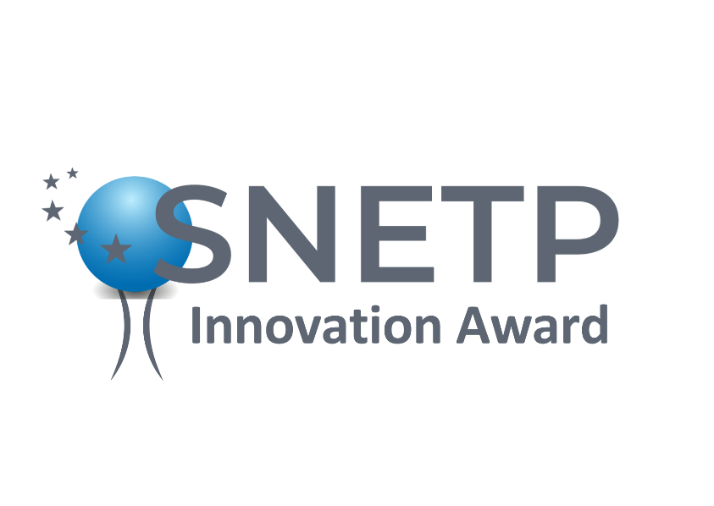

SNETP Innovation Award

Template for application

Date: 26/03/2024

Contact details of the PhD
Name:
Institution:
Tel:
E-mail:

Basic biography (500 words)

- Short description of the personal project and its timeline and the motivation of the applicant (500 words)

- PhD topic – research objectives, identified challenges, methodology employed, and collaborations (500 words)

CV (1 page )

In accordance with the EU General Data Protection Regulation (EU 2016/679), your personal data will not be neither used for commercial purposes nor put at the disposal of third parties except members of the Jury.

